# Login Integration Instructions:

This file explains how to set up a new authentication application using OKTA and adding users to it.

## Creating an OKTA account.

To create an OKTA account first go to <https://developer.okta.com/signup/> and file the prompted fields as shown in Figure 1.

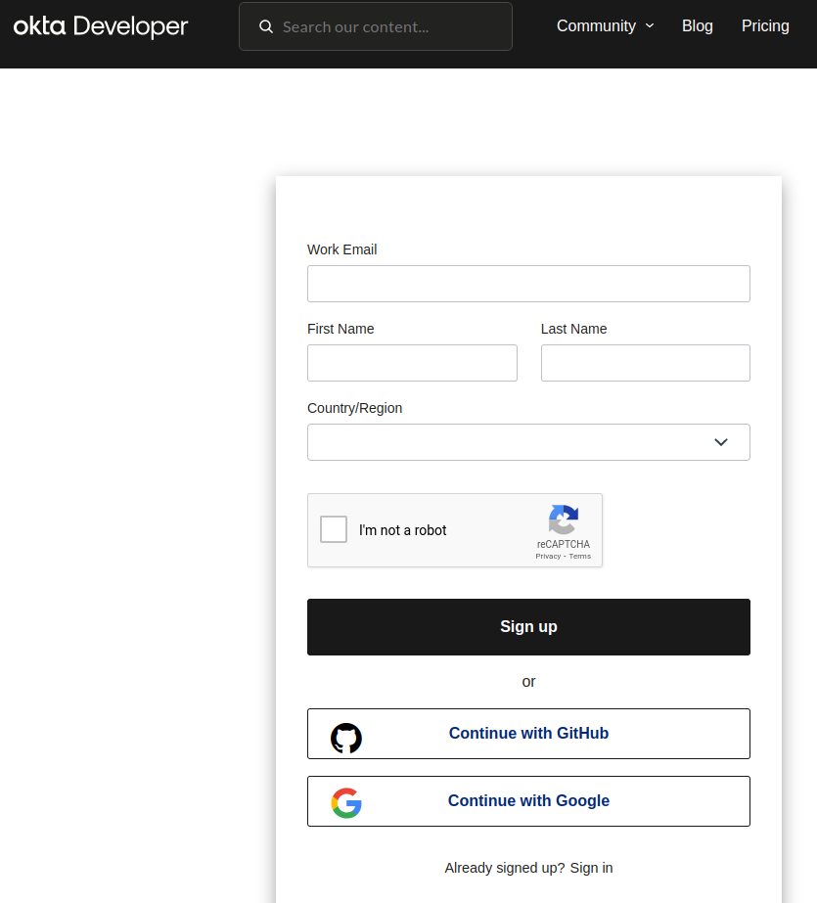

Figure 1

## Creating an OKTA application.

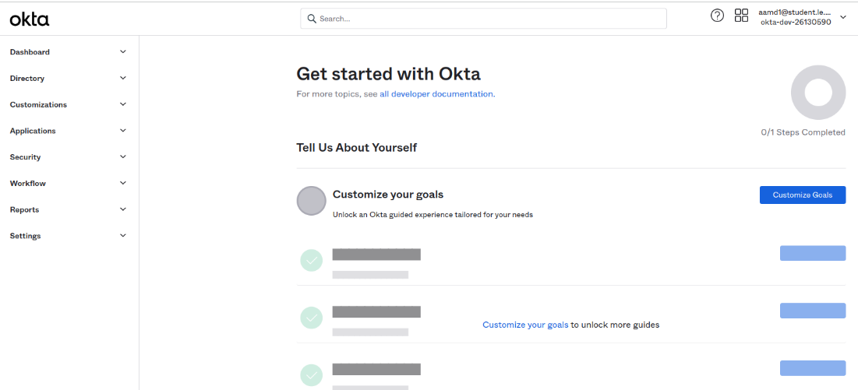

Figure 2

To create an okta application, go to OKTA main page as shown in Figure 2, https://dev-<YOUR UNIQUE NUMBER>-admin.okta.com/admin/getting-started, then open the “Applications” branch at the left of main page and choose “Applications” as shown in Figure 3.

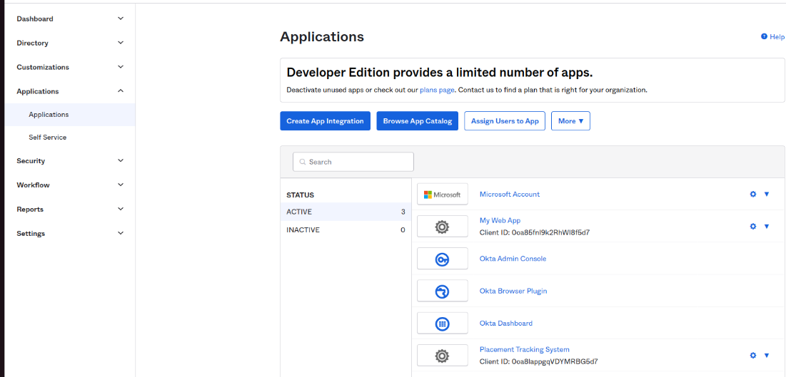

Figure 3

After that, click on “Create App Integration” then select “OIDC - OpenID Connect” and “Web Application” as the application type as Shown in Figure 4.

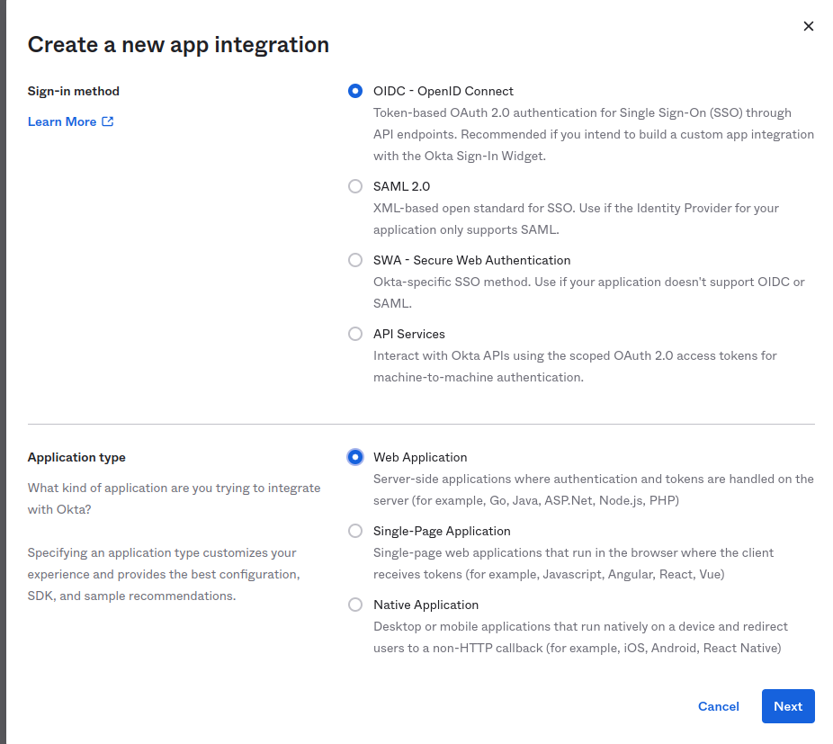

Figure 4

Choose an “App integration name” and click on save as shown in Figure 5.

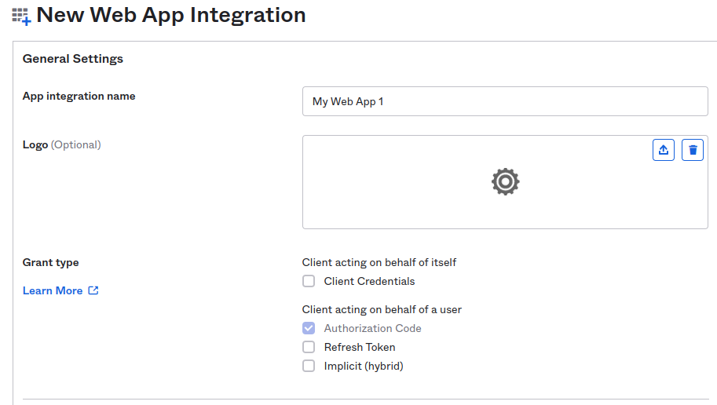

Figure 5

## Integrate the new APP integration into OKTA

In order to add the new app integration, open the “application. properties” located in the resource folder (resources/application.properties).

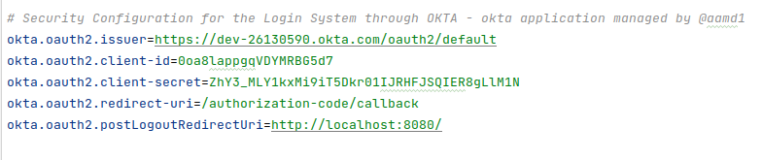

Figure 6

At the end, replace the issuer, client-id and client-secret with the new configuration found in the application page as shown in Figure 7.

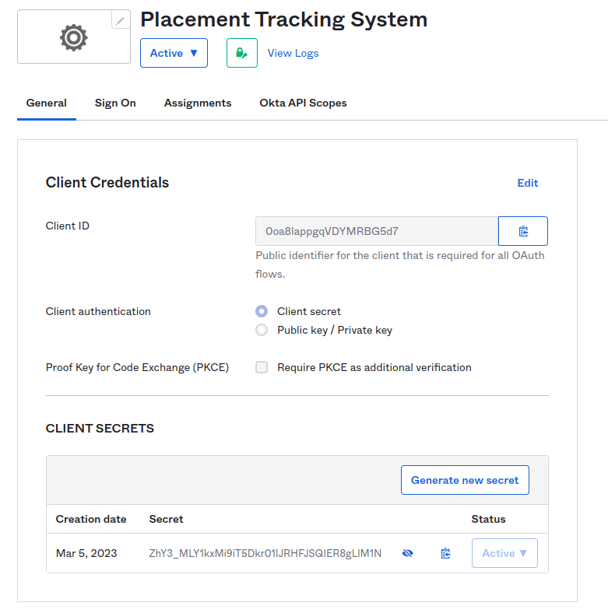

Figure 7